Dear WA IEEE members,

You are invited to the Power & Energy Society’s (PES) first event of 2019, where Dr.Natalia Kostecki will be presenting on “Electricity Markets, Rules and Regulations in WA”.

Natalia joined AEMO in September 2017 with a brief to facilitate improvements to market and system operation. This includes provision of subject matter expert advice on Wholesale Electricity Market regulation, operation and access to support rule development and the implementation of the McGowan government’s proposed reforms for the South-West Interconnected System and the Pilbara. Dr.Kostecki also advises on special projects such as distributed energy resource integration and the Kalgoorlie virtual power plant trial.

As part of the event, we will be presenting the Australasian Committee for Power Engineering (ACPE) 2018 Lifetime Achievement Award to the family of Professor Kit Po Wong and the IEEE 2018 Outstanding Engineer Award to Tyrone Fernando. Please join us in celebrating their achievements.

Event details are listed below.

Date: 28 February 2019
Where: Lecture Theatre, Central Park Building, 152 St Georges Terrace Perth
Time: 5:30 – Electricity Markets, Rules and Regulations in WA
6:30 – Presentation of ACPE Lifetime Achievement Award
6:45 – Presentation of IEEE 2018 Outstanding Engineer Award
Fee: Free
Registration: Registration is essential. Please contact Michelle Kenworthy-Groen (Michelle.Kenworthy-Groen@aemo.com.au, 08 9469 9977)

Short biography – Dr.Natalia Kostecki

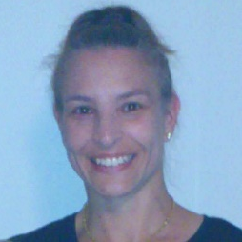
Dr. Kostecki PhD BA(Hons), received her doctorate (Political Science) from the University of Western Australia in 2005. She has worked in the agriculture, transport and energy portfolio areas developing policy and implementing projects that delivered on Western Australian Government imperatives. Her energy work experience includes Project Leads for the Network Connect and Access project, the Power System Security and Reliability project and the Institutional Arrangements project, Electricity Market Review Reform Program (2014 – 2017), Public Utilities Office; Acting Assistant Director Markets (2013-2014) and Project Lead Gas Services Information Project (2011-2013), Office of Energy.

